234. Palindrome Linked List
Easy
Topics
Companies
Given the head of a singly linked list, return true if it is a
palindrome
or false otherwise.

Example 1:
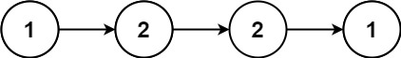
Input: head = [1,2,2,1]
Output: true
Example 2:
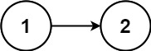
Input: head = [1,2]
Output: false

Constraints:
- The number of nodes in the list is in the range [1, 105].
- 0 <= Node.val <= 9

